Quiz #5 Study Guide
Note:
This quiz is based on pages 121-130 in A Pocket Style Manual, a document appearing on the course Web site, and two student essays also appearing on the course Web site. Before the beginning of the next class, print these two essays appearing on the course Web site: “Informative Essay (A Famous Manmade Structure/The Robot Building)” and “Informative Essay (A Famous Manmade Structure/The Tree of Life).” Bring both of these essays to class.
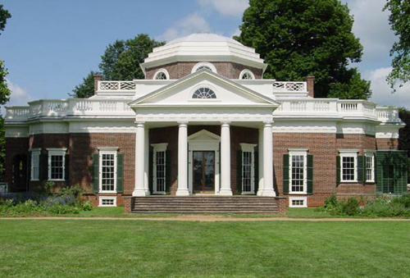
General Items:
- Bring a sheet of loose-leaf paper (the kind without the ripped edges) and a pen with black or blue ink.
- To complete the quiz, you will use one of the two student essays identified in the preceding section. The instructor will give copies of the quiz only to those students who have printed copies of these two essays. Students cannot borrow another student’s printed student essay after that student has completed the quiz.
- Students must prepare for the quiz before the beginning of the next class. Otherwise, they may discover that they cannot answer all of the quiz items in the allotted time.
- The quiz has four items, two calling for brief responses and two involving multiple choice.

Points to Guide Studying:
- Read pages 121-130 in A Pocket Style Manual to become familiar with the various forms of MLA in-text citations and parenthetical references.
- Read the document titled “MLA In-Text Citations and Parenthetical References (An Overview),” which is located on the course Web site in the section titled “Freshman Composition I (In-Text Citations and Parenthetical References).” In fact, the instructor based the quiz on this document. Therefore, if you are familiar with its contents, you should encounter few, if any difficulties when completing the quiz.

